Accommodations Assignment

Student: Marcus

Math Lesson: Finding the Slope of a Line

Alison Nardini

SPED 405

Carty

November 30, 2011

*Name:* Alison Nardini

*Date:* 11/3/11

*Grade Level:* 8th

*Course:* Algebra 1

*Time Allotted:* 50 Minutes

*Number of Students:* 20

**Modifications to the lesson plan are made in RED.

1. Goal(s):
   1. Common Core Mathematics Standards:
      1. 8.EE: Understanding the connections between proportional relationships, lines, and linear equations.
         1. Graph proportional relationships, interpreting the unit rate as the slope of the graph. Compare two different proportional relationships represented in different ways. *For example, compare a distance-time graph to a distance-time equation to determine which of two moving objects has greater speed.*
         2. Derive the equation *y* = *mx* for a line through the origin and the equation *y* = *mx* + *b* for a line intercepting the vertical axis at *b.*
   2. Common Core Standards for Mathematical Practice:
      1. Model with mathematics
         1. They are able to identify important quantities in a practical situation and map their relationships using such tools as diagrams, two-way tables, graphs, flowcharts and formulas. They can analyze those relationships mathematically to draw conclusions.
2. Objective(s):
   1. Students can recall the two definitions of slope: Rise/run and y2-y1/x2-x1
   2. Given the graph of a line, Students can classify the line as having a positive slope, negative slope, zero slope, or undefined slope.
   3. Given the graph of a line, Students can calculate the slope.
   4. Given the ordered pairs of two points on a line, students can calculate the slope.
3. Materials and Resources
   1. Note Sheet
   2. Pencil
   3. Worksheet/Homework
   4. Projector
   5. Document Camera
4. Motivation
   1. Show video that gives a real-life context to slope.
      1. <http://prezi.com/zf8wis33bsnw/test/>
         1. I included this video, rather than just notes to make the lesson not only more engaging for students and to spark excitement, but also, Marcus has difficulty reading and picking up on important in formation, so this is a different delivery tactic that should help Marcus retain the important information.
5. Lesson Procedure
   1. Warm Up (6 minutes)
      1. One problem: Graph from a table of values.
   2. Pass out notes sheet.
   3. Show Video and have class discussion as mentioned above under “motivation”(6 minutes)
      1. Tell students to fill in as much as they can on their note sheets
         1. Marcus has a modified notes sheet that states more clear what is supposed to be put in the notes. This will help Marcus focus his attention in on what is important in the video.
         2. Positive, Negative, Zero, Undefined. Have the students fill in the note sheet with the terms next to the graphs.
      2. Have a class discussion about how we can describe the steepmenss of mountains, hills, stairs, and relate it back to lines. Uphill vs. downhill lines.
         1. During this discussion, touch on what students should have written down on their notes sheets during the prezi. This way, Marcus, and the rest of the class, can have the information they may have overlooked.
   4. Define Slope (5 minutes)
      1. Slope = rise/run
      2. Rise/Run
         1. What is rise?
            1. Up and down in the y direction
            2. Count the rise first before you count the run to avoid missing negative signs.
         2. What is run?
            1. Left and right in the x direction.

Be sure to reiterate that these definitions and concepts go into the notes where these terms are written. This way, Marcus will know that this information is relevant and should go in the notes.

* + 1. Change in Y/Change in X
       1. Change in Y is the Rise
       2. Change is X is the Run.
       3. Can be calculated given a line or given two points with out a graph.
    2. Explain that you can find the slope of a line given a graph or two points on the line.
    3. Explain that the slope is the rate of change of the line.
       1. The rate of change tells, on average, how a quantity is changing over time.
  1. Examples (10-15 minutes) As a class.
     1. Rise/Run given a graph.
        1. How to find two points on the line.
           1. Points must be on the line
           2. Best if you choose whole numbers (i.e. On the corner of the grids) to avoid estimation.
        2. Explain how to make the right triangle.
     2. Example given two points on a line.
  2. Word problems
     1. Walk through the problem with the students before they work on their own. Prompt them to see what is important in the problem and how to read the graph.
        1. Marcus won’t feel as lost when asked to complete the word problem on his own if it is first set up for him. Also, the word problems on the worksheet won’t seem so daunting.
     2. Give students time to work on the word problems on their own for about 5 minutes before finishing them as a class. This will be a challenge for students so walk around to make sure students are on task.
        1. The word problems have the important information bolded so that Marcus can complete the problem without getting stuck on the words.
  3. Go through number 11 on the worksheet as a class. (5 minutes)
  4. Time to work on worksheet.
     1. This is a good time to check in with Marcus or note whether or not he is moving along with the material. You can spend some extra time with Marcus while the class quietly works on the worksheet.
     2. Marcus’s worksheet has modifications. The word problems are bolded.

1. Closure
   1. Have students fill in the “summary” section in their notes
      1. Redefine Slope as Rise/Run
      2. Talk about how to choose points on a line
      3. Explain that a good way to check if your slope is correct is to look at the direction the line is going.
2. Anticipated Student Responses
   1. Not making right triangles to calculate rise/run
      1. It’s important to make a right triangle so we know exactly how much we are running and how much we are rising. If we make a random triangle, we can’t easily count the grid lines. The lines must go strait up or down from the first point and straight to the second point.
   2. Having trouble choosing points on a line
      1. Remember that the grid lines represent a whole number. They go 1, 2, 3, and so on. Each line is one unit, so it’s best if we put our points at the ‘corners’.
      2. Draw a picture. Explain that if you zoom into the grid, you get a cross where two whole number points meet. These are the best places to put our points so we don’t have to estimate.
      3. Ask the class what the ordered pair would be for a floating point. Show them that having a whole number is better.
   3. Mixing up rise and run.
      1. Rise is up and down. Run is left and right.
   4. Missing the negative sign when there should be a negative slope.
      1. Explain that if you have to go up to reach the other point, the rise is positive. If you have to go down to reach the other point, the rise is negative.

**Instructional Strategy and Accommodations Selection:**

Brainstorming for Differentiation/Universal Design/Accommodations

**Student** for whom plan is being made**: _____Diego** or  **__X___Marcus** or ______**Jenna or _______ Curtis**

**Brief Description of the lesson:**

The lesson is on the topic of slope. It will be the first time the students are introduced to the topic and will be asked to calculate the slope of given lines, with and without given points, as well as ask a few word problems that apply the concept of slope to problems in context.

The beginning of class will be a warm up, to review another way of graphing they have previously learned: Graphing from a Table of Values. After this warm-up, I will show a prezi video I created with pictures of mountains and stairs with lines to give them a context to what slope is. This video will also contain important information that they will be asked to write down on their notes sheet to the best of their ability.

I will give a lecture on the definition of slope and how to find slope both from a graph and two given points.

At the end of the lecture, students will have time to complete their practice worksheet.

**Directions:** Complete the following four charts in preparation of your final Accommodations assignment. There may be some overlap between categories / charts. You may copy/paste and or indicate this by referencing the previous table (e.g. “See table 1, row 3”)

Type directly in the chart. You may add or delete rows in the charts as needed by clicking on any cell in the chart in the row where you wish to add or delete rows and then going to “Table” in the top menu and then “Insert” or “Delete.”

|  |  |  |  |
| --- | --- | --- | --- |
| **Table One: Input**  Consider the following for what is being taught (What YOU are doing / presenting / facilitating) | | | |
| Aspect of the lesson that may need to be differentiated or accommodated | Student characteristic(s) which may necessitate changes to the input of the lesson: | Suggested Differentiation / Universal Design / Assistive Technology / Accommodation | Explanation of how the previous suggestion will benefit the chosen student |
| Having the students note what is important in the opening video. | Marcus has trouble picking out what is important and what is not important in word problems, this could be the case with the video as well. | Create a notes sheet that gives hints as to what to look for. | Marcus will know what to look for in the video and how to write it on the notes sheet. |
| Asking the class to work on a word problem in the notes and at the end of the lecture. | Marcus struggles with word problems, so setting the students loose to work on the problem may need to be changed. | Set up the problem with the class. Create dialogue about what we need to know to solve this problem and then once the students have gathered that information, they can finish the problem on their own. | Marcus won’t feel overwhelmed by this problem. Since it is the first word problem involving slope, it could scare him off of the rest of the lesson. He also probably isn’t the only one who doesn’t know where to start so it will be helpful for the class. |
| Giving the students individual work time with an assignment that gets a little bit harder as the problems go on. | Marcus has trouble making connections with what he learns. He might struggle taking what we did as a class and putting onto his own paper. | When the students start to work on their assignments, check in with Marcus and see how he is progressing. Explain to him that all problems are just like the ones in the example. I will give him/others nearby a little extra help before I require them to do the assignments on their own. | Not letting Marcus get too behind won’t make him frustrated or turn him off to the class. He may just need some more explanation since the assignment doesn’t have many word problems. The main point of the lesson is to calculate the slope. |

|  |  |  |  |
| --- | --- | --- | --- |
| **Table Two: Output**  Consider the following for what the STUDENT is being asked to do during the lesson | | | |
| Aspect of the lesson that may need to be differentiated / accommodated or changed | Student characteristic(s) which may necessitate changes to the output of the lesson: | Suggested Differentiation / Universal Design / Assistive Technology / Accommodation | Explanation of how the previous suggestion will benefit the chosen student |
| Writing down the important pieces of the video on slope. | Marcus may have trouble deciding what is important information. | I created a note sheet that gives hints as to what information I would like for them to write down without telling them exactly what I’m looking for. We will also discuss the topics after the video to make sure the students have the information correctly written down. | This will benefit Marcus because he can look at his note sheet and see what I am asking I’m to write down. This way, he doesn’t have to decide what is important to write down, rather he just need to pay attention to the video. |
| Starting the last problem on the notes sheet on their own. | Having trouble getting started due to struggling with comprehension and treating all information given in the problem as relevant. | Setting up the problem as a class and letting them solve it on their own. | This is the first word problem exposed to the students in this chapter. Many students will probably not know where to begin. Setting up the problem as a class will help Marcus see where the information is coming from and help him solve the problem. |
| The word problems at the end of the worksheet. | Marcus has difficulty deciding which information is necessary to solve the problem. | Bold important information and provide a hint that encourages Marcus to draw a picture. | There is no extraneous information relevant to the problems, but it may be hard for Marcus to visualize what the problem is asking. |

|  |  |  |  |
| --- | --- | --- | --- |
| **Table Three: Behavioral Support**  Consider aspects of the lesson that may affect student behavior (grouping / scheduling / timing / expectations / materials, etc…) | | | |
| Aspect of the lesson that may need to be differentiated / accommodated or changed | Student characteristic(s) which may necessitate changes to the input of the lesson: | Suggested Differentiation / Universal Design / Assistive Technology / Accommodation | Explanation of how the previous suggestion will benefit the chosen student |
| Watching a video at the beginning of class. | Changes in routine can result in class disruption. | After the warm up, explain to the class that we will be doing something slightly different today. We are going to let a short video introduce the new topic. Explain the schedule of class. | Addressing the reason for the video as well as that the students will be watching it will make it so it is not an abruptly new way to teach a concept. I can’t know for sure, but this will most likely limit the need for bad behavior since this is the only slightly different thing about the class period. |
| Over half of the class time is individual work. | Unexpected noises can result in classroom disruption. | Consistently remind class to stay quiet and let others work. | If all of sudden, the students get out of hand, Marcus can be put over the edge. Being proactive will hopefully limit the chances of having any unexpected changes in volume. |

|  |  |  |  |
| --- | --- | --- | --- |
| **Table Four: Tests / Assessment / Evaluation**  Consider the following for the evaluation aspect(s) of the lesson | | | |
| Aspect of the lesson that may need to be differentiated / accommodated or changed | Student characteristic(s) which may necessitate changes to the input of the lesson: | Suggested Differentiation / Universal Design / Assistive Technology / Accommodation | Explanation of how the previous suggestion will benefit the chosen student |
| The worksheet will be graded. | Struggles with comprehension. | There are only two word problems on the worksheet. | Creating the worksheet this way will allow for Marcus, or any student, to struggle with the last two problems and still receive a good grade on the assignment. The more important of the concepts are not the word problems. |
| There will be a quiz at the end of the week including this lesson and the following two. | Struggles with comprehension. | There will be more word problems on the quiz. Highlight/bold important information for Marcus. Also, break down problems into smaller problems. | This way, Marcus will not get the problem incorrect due to his disability in deciding which information is relevant and which is not. He can demonstrate his knowledge of the concept if he is told what information to focus on. |

**Notes Monday November 7, 2011**

Name: _____________Class_________________________

Warm Up

Graph the following equation by using a table of values.

Y = -1/2 x + 1

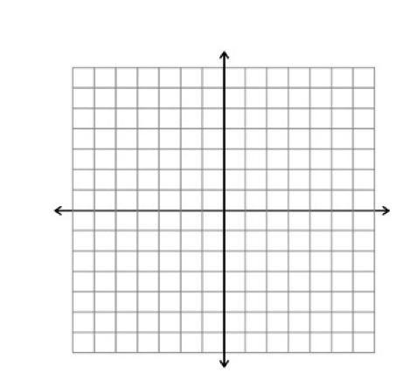

|  |  |
| --- | --- |
| X | Y |
| -5 |  |
| -3 |  |
| -1 |  |
| 0 |  |
| 1 |  |
| 5 |  |

Notes

Video Highlight:

______________ Negative ________________ Undefined

 Uphill ______________ Horizontal ______________

Slope =

Rise:

Run :

Rate of Change:

**Find the slope of the line. Find the slope of the line**

**through the two given points.**



 (0,5) (-3,-1)



The graph to the right shows the amount spent on food and drink at U.S. restaurants in recent years.

Find the rate of change for 1908-1990 and 1990-2000.

In 1995, the number of families with cable television was 20.0 million.  By the year 2008, there will be 27.6 families with cable television and enjoying every minute of it. Find the slope and describe what the slope represents.

Summary

Finding Slope Name:__________Class___________________

**Find the slope of the line through each pair of points.** Period:________

1. (-4,7),(-6,-4) 2. (17,-13),(17,8) 3.(3,0),(-11,-15)

4. (1,-4),(-2,-1) 5. (12,2),(-7,5) 6. (0,4),(5,9)

**Find the slope of each line.**

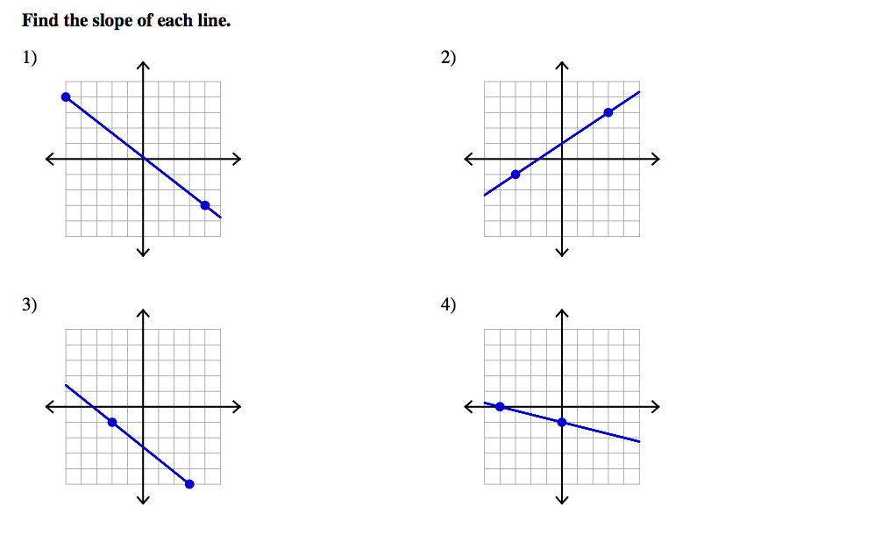

7.

10.

9.

8.

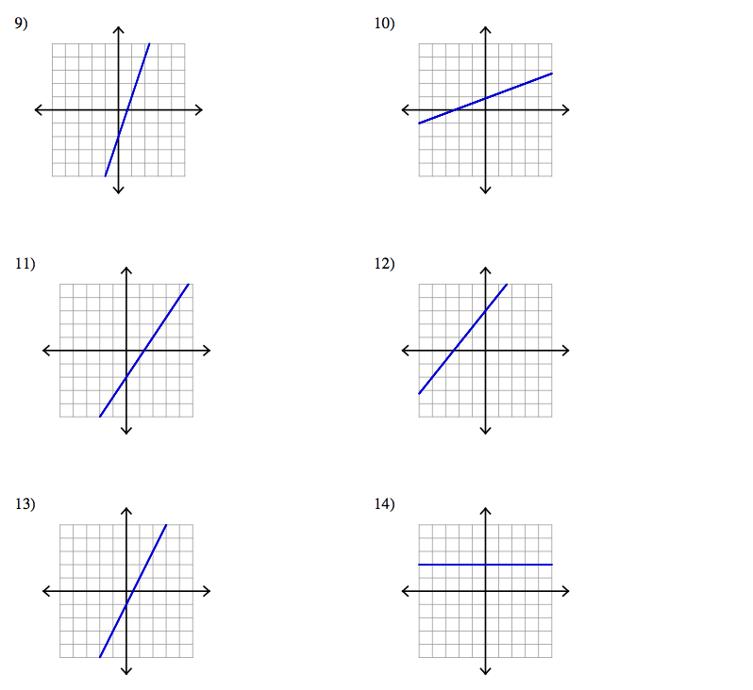

16.

15.

14.

13.

12.

11.

17. One particularly large ant hill found in 1997 measured 40 inches wide at the base and 18 inches high. What was the slope of the ant hill?

**Notes Monday November 7, 2011**

**Accommodated**

Name: __________Marcus________________________

Warm Up

Graph the following equation by using a table of values.

Y = -1/2 x + 1



|  |  |
| --- | --- |
| X | Y |
| -5 |  |
| -3 |  |
| -1 |  |
| 0 |  |
| 1 |  |
| 5 |  |

Notes

Video Highlights:

 ______________ Negative ________________ Undefined

 Uphill Downhill Horizontal Vertical

Slope = -------------

Rise:

Run:

Rate of Change:

1. **Find the slope of the line. 2. Find the slope of the line**

**through the two given points.**



 (0,5) (-3,-1)



3. The graph to the right shows the amount spent on food and drink at U.S. restaurants in recent years.

Find the rate of change for 1980-1990 and 1990-2000.

1. What is spent on food and drink in

1980?_________

1990?_________



1. What is the rise in the data from 1980 to 1990? (Use the graph to help determine what numbers correspond to the rise)
2. What is the run in the data from 1980 to 1990? (Use the graph to help determine what numbers correspond to the rise)

4. In **1995,** the number of families with cable television was **20.0 million**.

By the year **2008,** there will be **27.6 million** families with cable television and enjoying every minute of it.

a)Find the slope

b) Describe what the slope represents.

Summary

Finding Slope Name:__________Marcus_________________

**Accommodated**

**Find the slope of the line through each pair of points.** Period:________

1. (-4,7),(-6,-4) 2. (17,-13),(17,8) 3.(3,0),(-11,-15)

4. (1,-4),(-2,-1) 5. (12,2),(-7,5) 6. (0,4),(5,9)

**Find the slope of each line.**



7.

10.

9.

8.

17. One particularly large anthill found in 1997 measured **40 inches wide** at the base and **18 inches high**. What was the slope of the anthill?

14.

13.

12.

11.

**Quiz**

Name:__________Class______________________

**Find the slope.**

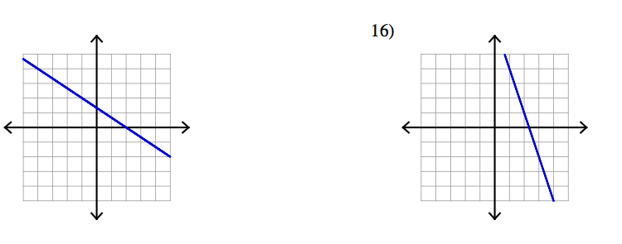

1.

2.

3. (-1,4),(5,8)

**Identify the slope and y-intercept of each equation and sketch the graph.**

****5. 2x-6y=3 6. 4y=-x+2

**Write the equation of the line.**

7. The line that passes through point (3,3) with slope -.

8. The line that passes through (-6,-2) with slope 

9. Find the slope of a line that passes through the origin and point (r,-s).

10. A ladder reaches a height of 16 feet on a wall. If the bottom of the ladder is placed 4 feet away from the wall, what is the slope of the ladder as a positive number?

11. Why is slope important in architecture?

Include the following in your answer:

* An explanation of how to find the slope of a roof, and
* A comparison of the appearance of rooms with different slopes.

**Accommodated**

**Quiz**

Name:_____________Marcus___________________

**Find the slope.**



1.

2.

3. (-1,4),(5,8)

**Identify the slope and y-intercept of each equation and sketch the graph.**

****5. 2x-6y=3 6. 4y=-x+2

**Write the equation of the line.**

7. The line that passes through point (3,3) with slope -.

8. The line that passes through (-6,-2) with slope 

9) Find the slope of a line that passes through the origin and point (r,-s).



a) Plot the point (r,-s) to the right.

b) What is the rise?_________ run?___________

c) What is the slope?

10)A ladder reaches **a height of 16 feet** **on a wall**. If the bottom of the ladder is placed **4 feet away from the wall**, what is the slope of the ladder as a positive number?

(Hint: First draw a picture of the ladder)

11) Why is slope important in architecture?

Include the following in your answer:

* An explanation of how to find the slope of a roof, and
* A comparison of the appearance of rooms with different slopes.

**Co-Teaching Statement**

For this lesson, it would be great to have a co-teacher. I think this lesson could be done either team teaching or one teach-one assisting. I would prefer the co-teaching because I personally think it is more effective for students. There are many natural breaks between examples or discussions that the teachers could switch roles.

Having another teacher in the room will be especially helpful when the students are working on their worksheets. If Marcus, or any other student, is struggling with the material, we now have two teachers that can give extra attention and shed more light onto the material.

The natural progression of the teaching could go as follows: Teacher 1: Conduct Warm-up, show video, lead discussion. Teacher 2: Run through the examples and introduce worksheet. Both teachers: walk around and assist students during the class time. Teacher 1: Go through summary with the class before dismissal.

Since this lesson has a good chunck of classroom time to work individually, I think that the co-teaching method one teach-one assist would also work because there are only 3 examples to do for the class before they start doing their worksheet. Either teacher could go through the warm up and examples.

**Reflection**

Because of Marcus’s disability in reading comprehension, I had to modify my lesson a little bit. Most of my lesson is simple math that Marcus shouldn’t have a problem with but there are more challenging application and word problems I had to modify.

Here is a summary of changes I made and why:

**Notes**

1. Added terms and graphs to the notes that he will take during the movie.
   1. This will help guide Marcus to look for certain things in the video. There are less things to look for on his worksheet to help him get all of the information I am asking for. The video itself may also help with comprehension because there are pictures and it is a different way to give information rather than me just talking and the students writing.
2. Added a line after slope =.
   1. This is a small change that just helps guide what I am looking for at this point in the notes. He will just right “Rise” on the top and “Run” on the bottom.
3. Broke up the first word problem in to 3 parts and bolded the important information.
   1. This will be the first word problem that the class is doing regarding slope. I will start the problem with them for extra help. I also added different parts for Marcus to help him learn to read what the graph is saying and how to read it.
4. Broke up the second word problem into 2 parts and bolded the important information.
   1. Like the last one, this will help guide Marcus to use the important information as well as set up the problem.

**Worksheet**

1. Took away two problems on the back of the page.
   1. The word problem at the end may take a little more time for Marcus to complete so I eliminated two of the problems calculating slope. I don’t think that two more problems will hinder his ability to practice as well as give him some more time to complete the most important problem.
2. Bolded important information in the word problem
   1. Bolding the important information will help Marcus focus on what is important to solve the problem and give him the ability to show me his knowledge of he math without falling behind due to reading the problem.

**Quiz**

1. Broke up number 9 into 3 parts and provided a graph.
   1. The original question asks a vague question about slope. I broke up this question into three parts to make the problem easier to solve. Providing a graph helps Marcus relate point (r,-s) to a point on the graph. I then asked separately what the rise is and what the run to make the problem a little easier.
2. Bolded important information in number 10.
   1. This way Marcus isn’t struggling to figure out what information he needs to use in order to solve the problem. There isn’t too much extraneous information in the question so bolding what is important can help eliminate the struggle he might have with comprehension.
3. Added a hint to #10.
   1. Without giving away the answer, I think that the hint is a helpful guide. Asking Marcus to draw a picture will help him visualize what the problem is asking and make it easier to use the numbers given to calculate the slope.

What I find difficult about differentiating Mathematics is that a lot of times, I feel like I am taking away the thinking involved to set up the problems, which to me, is the most important part. Breaking up the problem or asking certain additional questions takes away the component that the students have to apply the computational aspect of the mathematics.

In this lesson, I didn’t feel like there was too much to modify. I created this lesson with diverse students in mind so I tried to make it accessible for ‘most’ students. It is also hard to modify a lesson without actually knowing the student. You might not have to break up every single word problem, especially if they are short, for Marcus since he does not struggle with the computational part of the mathematics, just the reading. Overall, I enjoyed this assignment because it truly made me think of all the ways possible to modify a mathematics lesson and really think about how I could help not only Marcus but all students in my classroom.

**The General Educator’s Role in Special Education**

**SPED 405B - Carty**

# Fall 2011

**Accommodations assignment RUBRIC**

Name: Alison Nardini

Signature: Alison Nardini

|  |  |  |
| --- | --- | --- |
| Criteria | Points | Comments |
| **Brainstorming checklist** attached and clearly addresses these things *for the lesson provided*:  Input (what the teacher does/instruction)  Output (what the student does / produces)  Student Behavior  Testing / Evaluation  *Note: There may be crossover between categories* | /15 |  |
| Lesson Plan makes it very clear where accommodations were made compared to the original. (fonts, underlined, bold, color, headings, etc…) | /5 |  |
| **Accommodations** are present for:   * a reading component of some kind * at least one handout * a student product (something that the student will produce) * preferably, some sort of student-centered or guided activity * an assessment of student learning that targets your lesson objective(s) | /30 |  |
| Accommodations are valid and meet the needs of the student chosen. There are no components of the lesson that were not addressed and remain a hindrance to learning for the student chosen. |
| Reading component – clearly labeled as original and accommodated and text is at a lower level ./ more accessible |
| **Description of a way to co-teach this lesson includes:**  *Model(s) of co-teaching you would use of those discussed in class and why it/they would work for this lesson.  *The responsibilities of each teacher during the lesson (where will they be? How will students be grouped? What will each teacher be doing instructionally during the class period?) | /10 |  |
| **Reflection includes:**  *A clear, succinct explanation and rationale for the changes and accommodations made to my lesson and how they match the needs of my selected student.  *An explanation of where the lesson did not need to be changed or accommodated since it already was planned in such a way that it met the needs of the student chosen.  *Overall reflection on the process / assignment. | /10 |  |
| **TOTAL** | /70 |  |